CSUSB International Studies

Mobile Application

**Software Requirements Specifications**

**Version 1.4**

March 15, 2015

Prepared by: Advisor:

Project Manager: Claudia Tristan, Arturo I. Concepcion

Assistant Project Manager: Craig Mulari

Graphic Designer: Diane Balane

Project Members:

Thomas Clyde, Jason Treat,

Shea Grotke, Richard Arevalo

Table of Contents

1. Introduction

1.1 Purpose………….……………………………………………………………………… 1

1.2 Scope…………………………………………………………………………………… 1

1.3 Definitions, Acronyms, and Abbreviations...………………………………………… 1

1.4 Reference.……………………………………………………………………………… 2

1.5 Overview..……………………………….……………………………………………… 2

2. Overall Description

2.1 Product Perspectives.………………………………………………………………… 4

2.1.1 System Interfaces (deployment diagram) …………..…………………….. 5

2.1.2 User Interfaces………………………………………..……………………… 6

2.1.3 Software Interfaces………………………………….……………………..... 6

2.1.4 Communication Interfaces……………………….…………………………. 6

2.1.5 Memory………………………………………..……………………………… 6

2.1.6 Operation ……………………………………….……………………………. 7

2.1.7 Site Adaptation ……………………………………………………………… 7

2.2 Product Functions...…………………………………………………………………… 8

2.3 User Characteristics ..………………………………………………………………… 9

2.4 Constraints...…………………………………………………………………………… 9

2.5 Assumptions and Dependencies..…………………………………………………… 9

3. Specific Requirements

3.1 External Interface Requirements...…………………………………………………… 9

3.1.1 User Interfaces……………………………………………………………… 10

3.1.2 Hardware Interfaces………………………………………………………... 10

3.1.3 Software Interfaces…………………………………………………………. 10

3.1.4 Communication Interfaces…………………………………………………. 10

3.2 Functional Requirements…………………………………………………………… 11

3.3 Performance Requirements………………………………………………………... 11

3.4 Design Constraints………………………………………………………………….. 11

3.5 Software System Attributes…………………………………………………………... 11

**1. Introduction**

**1.1 Purpose**

The purpose of this software requirements specifications is to provide a detailed outline of the specific requirements and descriptions of the International Studies Mobile App. This document is written for the Center for Dr. Rueyling Chuang, Director of International Studies & Programs. This project will be done as part of the requirement for CSE 455 (Software Engineering) under Dr. Concepcion.

**1.2 Scope**

The software that will be developed will be a mobile application for the use of the faculty, staff and students of the Center for International Studies Programs.

The target audience for this mobile application are all current and potential faculty, staff, and students pertaining to International Studies and Programs. This application will be designed to inform and assist students, faculty and staff in gaining access to important information and documents needed for specific programs, registration, and services related to International Studies.

This mobile application will attempt to reflect the information on the Center for International Studies and Programs website as well as other basic student information displayed on other sites such as CSUSB events and services.

-Target audience: Faculty, Staff, and Students with connections to International Studies

-Function: To inform and assist in gaining access to important information related to International Studies

-Target Devices: Android mobile phones and tablets

-No IOS version is currently planned for this iteration

-No ability to allow user to fill out forms this iteration

-No links to other applications planned for this iteration

**1.3 Definitions, Acronyms, and Abbreviations**

**Android**

**-**an open-source operating system used for smartphones and tablet computers

**Client**

**-**Dr.Rueyling Chuang

**Javascript**

**-**a dynamic computer programming language

**PHP**

**-**a server-side scripting language designed for web development but also used as a general purpose programming language.

**W3C**

**-**An acronym for *World Wide Web Consortium*, which is the international standards

organization for the World Wide Web.

**Mobile App**

**-**A software application designed for use on a mobile device such as a smartphone or tablet.

**Web**

**-**A term referring to the internet, or content derived from the internet.

**Smartphone**

**-**A mobile telephone with an operating system capable of running 3rd-party software.

**1.4 Reference**

Fowler, Martin. *UML Distilled Third Edition.* Boston: Addison-Wesley, 2004. Print.

IEEE Std 830-1998 Software Requirements Specifications

Allbee, Dylan and Schenk, Michael. *CSUSB Student Advising Mobile Application SRS*.

**1.5 Overview**

The rest of this document is organized into two sections. The second section describes an overall view of the different interfaces and characteristics of the mobile application. This also includes any constraints our application might have concerning older versions of operating systems. The third section describes in detail exactly what type of requirements will be implemented by our mobile application.

**2. Overall Description**

**2.1 Product Perspective**

This App will be designed for staff, faculty, and students with connections to International Studies programs. It will provide important information and links pertaining to International Studies programs and services.

**2.1.1 System Interfaces**

The app will mainly be accessing or redirecting to the CSUSB Web Server. Our own server will act as an intermediary and deal with any caching that is needed while also gathering new info from the CISP Web server. The International Studies app will have links within it that will simply open the Web browser on the user’s phone. This app will not be a Web App running on the smartphone; it will be a mobile app running on the smartphone.

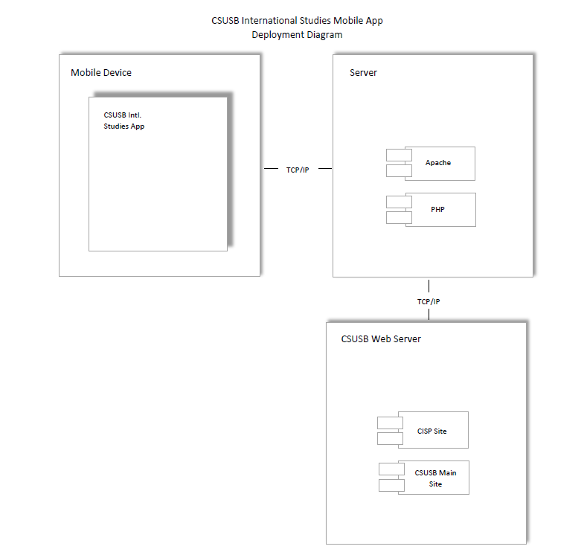

**2.1.2 User Interfaces**

The user will mainly access the app through the main categories on the front page. By tapping each category they will either link to a website on the CSUSB server or take the user to a static page within the app.

The main categories of the app were explicitly picked by the client and were made to their specifications. Beneath each main category will be a number of sub-categories which, once again, either lead to a URL or a static page. Each of these sub-categories were also defined by the client.

Since this is a school based app, the app will maintain the same blue color scheme in the logo. It will also contain theCSUSBlogo in the top of the main page of the International Studies app.

Frames: The Main Frame will consist of six buttons titled “About Us,” “Academic Advising,” “Admissions,” “Study Abroad,” “Exchange Program,” and “Other Resources.” These buttons, when pressed, will lead to six separate frames. The first frame contain an informational page and two buttons titled “ CISP Organizational Chart” which leads to a PDF and “CISP Staff” which leads an activity with information. The second frame will contain information as well as a button titled “Programs and Courses” which will lead to a frame with a button titled “Course Listings” which leads to a website and a button titled “GE Courses” which also leads to a website. It will also contain a button titled “Orientation and Testing” which will lead to a page containing three buttons titled “Orientation information, EPT and ELM Testing, and Vital Technology Videos,” each of which leads to a website. The third frame contains four buttons titled “Undergraduate Program, Graduate Programs, MBA Programs, and Access to CSU Mentor,” each of which lead to different websites. The fourth frame leads to a page with three buttons titled “Horizon Application, Browse Programs,” both of which lead to a website, and “Gilham Scholarship” which leads to a page containing a button “Apply” which leads to a website. The fifth frame contains information as well as two buttons titled “National Student Exchange Programs, and Exchange Program Financial Aid,” both of which lead to websites. The last frame contains seven buttons, “Find Health Insurance, Campus Map, Learn About Housing, View Application Deadlines, Registration and Discover Social Events,” each of which lead to a website and the seventh button, “News and Weather” leads to a page that contains information as well as two buttons titled “CSUSB Campus News” and CSUSB Campus Weather, both of which lead to respective websites.

**2.1.3 Software Interfaces**

The following technologies and programming languages will be used in this app’s development:

-Html

-Java

-Android Studio

-Android OS

-MS Windows OS

-Linux OS

-Github

-Google Drive

**2.1.4 Communication Interfaces**

-There are two primary communication networks established:

**Server to CSUSB Website**

TCP/IP Connection over port 80

**Mobile Application to Server**

TCP/IP Connection over port 80

**2.1.5 Memory**

-We are adding the following memory constraints to the application for ease of download and performance.

* The application will not exceed 50MB of RAM.
* The application will use no more than 5MB of disk space.

-The actual values will vary depending on the phone.

**2.1.6 Operation**  
 The application will run 24 hours a day 360 days a year. Five days a year will be reserved for maintenance purposes.

**2.1.7 Site Adaptation Requirements**

Not applicable.

**2.2 Product Functions**

The following diagram (Figure 2.1) is a complete description of the application use cases:

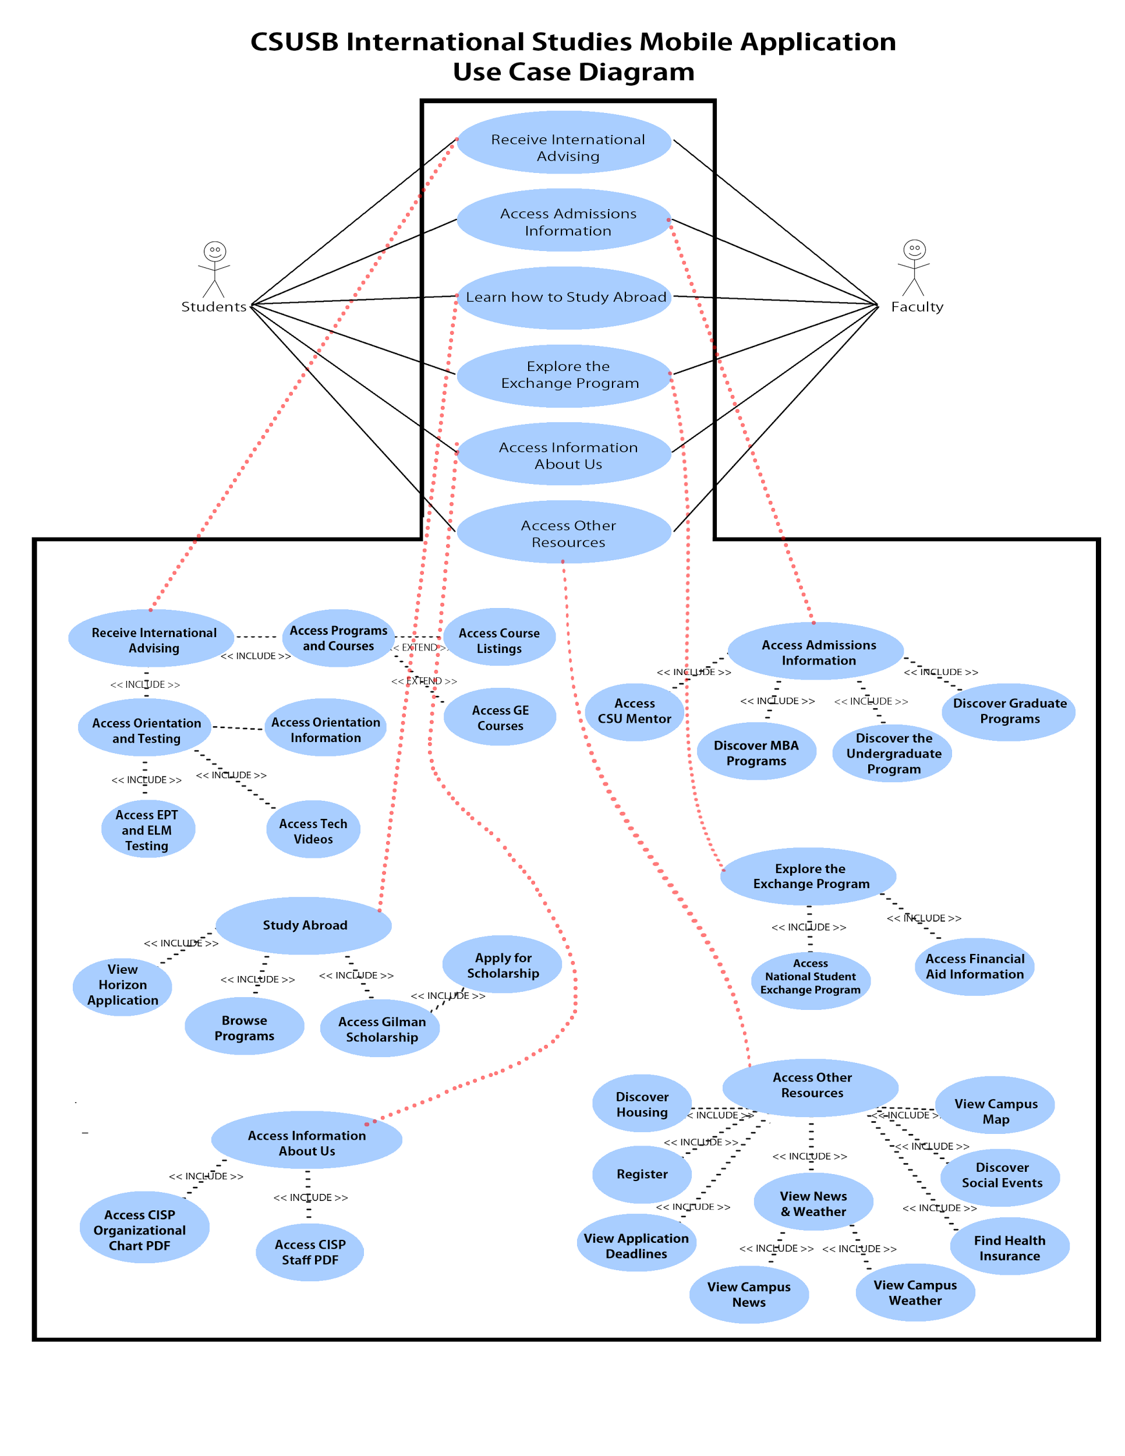

Figure 1: CSUSB International Studies Use Case Diagram

**2.3 User Characteristics**

The “Student” is a current student of CSUSB or a possible future student of CSUSB.

The “Faculty” is a current faculty member of CSUSB.

Each user may be capable of performing the following tasks with this application:

-Read the contents of the page

-Navigate and interact with the application through a touch screen device

-Type or speak, if offered by device manufacturer’s software, through device to

input text.

-Click various links to outside websites

**2.4 Constraints**

**2.4.1 Operating System**

In order to use the application a tablet or phone is required. The supported operating system will be Android 4.0+ and any older versions will not be supported.

**2.4.2 Content Creation**

Data will be fetched automatically and no manual input will be needed to display or update the application’s content.

**2.4.3 Web Accessibility**

This application will adhere to standard web accessibility guidelines as stated by W3C.

http://www.w3.org/TR/2008/REC-WCAG20-20081211/

**2.5 Assumptions and Dependencies**

- Application will be developed with native Android SDK.

We will require the following dependencies:

- Android 4.0+

- Installed web browser application. Must be compatible with Android 4.0+

**3. Specific Requirements**

**3.1 External Interface Requirements**

**3.1.1 User Interfaces**

- Read the contents of the page

- Navigate through touch screen

- Pages will consist of a main page with categories and sub-category frames within, as follows:

Frames: The Main Frame will consist of six buttons titled “About Us,” “Academic Advising,” “Admissions,” “Study Abroad,” “Exchange Program,” and “Other Resources.” These buttons, when pressed, will lead to six separate frames. The first frame contain an informational page and two buttons titled “ CISP Organizational Chart” which leads to a PDF and “CISP Staff” which leads an activity with information. The second frame will contain information as well as a button titled “Programs and Courses” which will lead to a frame with a button titled “Course Listings” which leads to a website and a button titled “GE Courses” which also leads to a website. It will also contain a button titled “Orientation and Testing” which will lead to a page containing three buttons titled “Orientation information, EPT and ELM Testing, and Vital Technology Videos,” each of which leads to a website. The third frame contains four buttons titled “Undergraduate Program, Graduate Programs, MBA Programs, and Access to CSU Mentor,” each of which lead to different websites. The fourth frame leads to a page with three buttons titled “Horizon Application, Browse Programs,” both of which lead to a website, and “Gilham Scholarship” which leads to a page containing a button “Apply” which leads to a website. The fifth frame contains information as well as two buttons titled “National Student Exchange Programs, and Exchange Program Financial Aid,” both of which lead to websites. The last frame contains seven buttons, “Find Health Insurance, Campus Map, Learn About Housing, View Application Deadlines, Registration and Discover Social Events,” each of which lead to a website and the seventh button, “News and Weather” leads to a page that contains information as well as two buttons titled “CSUSB Campus News” and CSUSB Campus Weather, both of which lead to respective websites.

**3.1.2 Hardware Interfaces**

Hardware interfaces will include:

-Touch Screen

-Microphone

-Physical Keypad (if present)

**3.1.3 Software Interfaces**

Software interfaces will include:

-Voice to text software

-Keypad input (if physical keypad not present)

**3.1.4 Communication Interfaces**

Communication Interfaces will include:

-Network Connection

**3.2 Functional requirements**

The mobile application will support the following functions.

- Information regarding international academic advising

- Information regarding international admissions for undergraduates, graduates and MBA.

- Information regarding the study abroad program that include deadlines, and forms (including the program application).

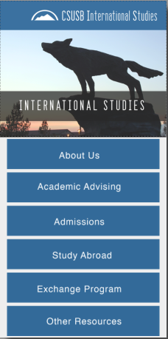

**3.3 Performance requirements**

Touch command will be the main access of these functions. The average load time for the app will be 4-6 seconds. However, load time depends on the mobile device and it’s hardware specifications.

A non-functional requirements necessary for this mobile application are that network connectivity. Without network connectivity the user will not access necessary links within the mobile app.

**3.4 Design constraints**

Some design constraints associated with this is to be able to have the graphics look and feel the same across different devices such as tablets and mobile phones.

**3.5 Software system attributes**

Software will have the listed functions above as well as future improvement/add-ons. Main focus is to get the general functions and layout of the application.